PARTNER SERVICES
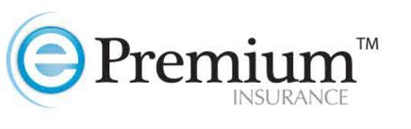
- Offers most robust renters insurance program in both the multifamily and student housing industry
- Helps properties maximize the returns on liability coverage of resident-caused damages
- Security deposit insurance to maximize financial protection of each unit
- Able to offer ancillary income opportunity through ePremium protect program
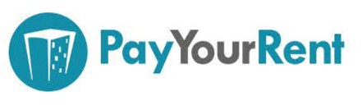
- Helps properties improve their rent payment collection process
- Has same day payment processing and next business day deposits
- PYR has a customizable portal that integrates with all the major PM companies like, ValencePM, Yardi, ResMan, and more
- Several ancillary features, i.e., maintenance requests, online rental applications, announcements and more
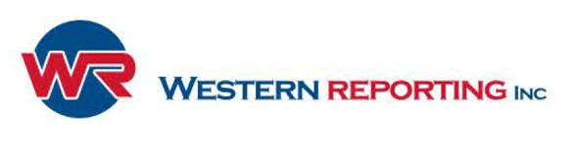
- Most Comprehensive resident/pre-employment screening
- Now offers service animal screening
- Integrates with major PM software including Yardi, MRI, ResMan, Valance PM, Property Boss and more!!!
- Customizable online applications
- Pricing is transaction or unit based with the lowest price in the industry with no annual contract
- WR works with small to large properties and communities
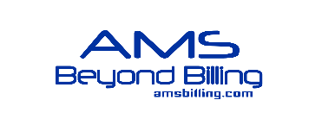 Utility Billing and sub-metering
- Utility Billing and sub-metering
- Payment collection by telephone, online, mail or through cash payment centers
- Fully integrated with your property management system
- Full page, postcard and electronic billing options
- Invoice processing, Regulatory Compliance and Analytics
- Integrates with your property management system
- File evictions online quickly and accurately according to local process and laws
- Portfolio Management with property-level functionality
- Track eviction activity and metrics across your portfolio
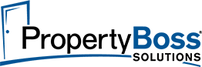
- Property Management Software for student, multifamily and single family housing
- Quickbooks integration
- Student bed tracking and student portals to make payments, create orders and renew leases
- Accept payments, document cloud storage, background screenings, maintenance tracking
- Automated lead to lease process and vacancies listing on our ILS feed

